20/09/2005
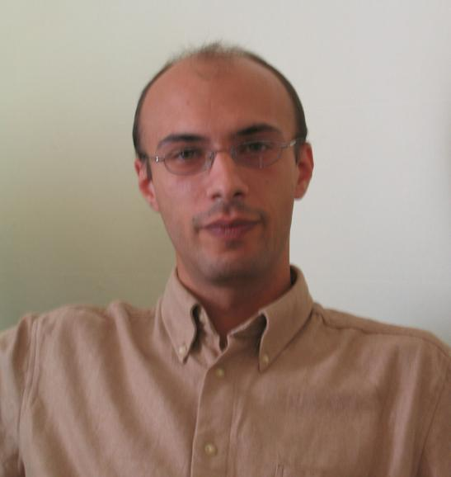
European
curriculum vitae
format

Personal information

Name |  | Zamfirescu, Constantin
Address |  | 1A, Prof. Petru Span, 550276, Sibiu, Romania
Telephone |  | +40-269-220426; +40-741-985970
Fax |  | +40-269-220426
E-mail |  | zbc@acm.org

Nationality |  | Romanian

Date of birth |  | [ 16, 11, 1972 ]

Work experience

• Dates (from – to) |  | 2004 – now
• Name and address of employer |  | Effective Decisions, Prof Pentru Span 1A
• Type of business or sector |  | R&D, ICT
• Occupation or position held |  | Manager
• Dates (from – to) |  | 2004- now
• Name and address of employer |  | “Lucian Blaga” University of Sibiu
• Type of business or sector |  | Education
• Occupation or position held |  | Lecturer
• Main activities and responsibilities |  | Teaching, research
• Dates (from – to) |  | 2001 – 2004
• Name and address of employer |  | Katholieke Univ. Leuven
• Type of business or sector |  | Education
• Occupation or position held |  | Associate researcher
• Main activities and responsibilities |  | R&D, Project Management
• Dates (from – to) |  | 1999-2000
• Name and address of employer |  | Lucian Blaga University of Sibiu
• Type of business or sector |  | Education
• Occupation or position held |  | Teaching assistant
• Main activities and responsibilities |  | Teaching
• Dates (from – to) |  | 1997-1999
• Name and address of employer |  | Raiffeisen Bank
• Type of business or sector |  | Backing
• Occupation or position held |  | System administrator
• Main activities and responsibilities |  | Programming, DB administrator

Education and training

• Dates (from – to) |  | 1991-1996
• Name and type of organization |  | “Lucian Blaga” University of Sibiu
• Principal subjects |  | Computer Science
• Title of qualification awarded |  | MSc

• Dates (from – to) |  | 1996-1997
• Name and type of organization |  | “Lucian Blaga” University of Sibiu
• Principal subjects |  | Distributed Systems
• Title of qualification awarded |  | Post university studies

• Dates (from – to) |  | Sept. 2004
• Name and type of organization |  | United Nation for Industrial Development - UNIDO
• Principal subjects |  | Foresight
• Title of qualification awarded |  | “Technology Foresight for practitioners”

• Dates (from – to) |  | 1999-2000; 2004-2005
• Name and type of organization |  | “Politehnica” University of Bucharest
• Principal subjects |  | Anthropocentric Group Decisions Support Systems
• Title of qualification awarded |  | PhD studies

Personal skills
and competences

Mother tongue |  | Romanian

Other languages

 |  | English
• Reading/Writing/Verbal skills |  | Excellent/Excellent/Good
 |  | French
• Reading/Writing/Verbal skills |  | Good/Basic/Good

Social skills  and competences |  | - Living and working in multicultural environments: Austria (1999, IST KNAG project), Spain (2000, TEMPUS Project Retraining Support for Small and Medium Enterprises), Belgium (2001-2003, GROWTH/RTD Project: Modular Plant Architecture), Italy (2002, European NoE Intelligent Control and Integrated Manufacturing Systems).  - Participation in EU projects and NoE: COST Action 269, User Aspects of ICTs, Copernicus "Medical Guideline Technology: Representing, Interpreting and Sharing Cost Effective Standards" – DGXIII, European NOE for Agent Based Computing, GOA Project: AgCo2 - Concerted Action on Agents for Coordination and Control

Organisational skills  and competences |  | - Coordination and administration of people, projects and budgets: EU GRD Project 1-2000-25065; “Future prospects in Romania” Project with Institute for Prospective Technological Studies, EC Joint Research Center; eCollaborativeDecisions Project, CEEX 2005.

Technical skills  and competences  . |  | - Group Decision Support Systems  - Project Management Tools  - ERP systems  - Discrete event simulation tools and Multi-Agent Systems

Foresight Activities |  | - FISTERA study: “Future prospects in Romania – Scenarios for the development of the Knowledge Society in Romania”, IPTS EC JRC  - “Foresight methods and IT tools for risk identification”, in “High risk processes and phenomena on national scale”, Romanian Academy Press, p. 365-380.  - Participation in FISTERA NoE, IPTS EC JRC: “Foresight on Information Society in Europe” Krynica, Poland, September, 2004.  - FP6-2004-KNOW-REG-2 project proposal: “Knowledge brokerage through Benchmarking of R&D Practices in less favoured regions.

