D/09/2005
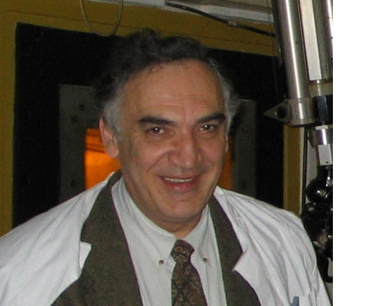to.jpg
European
curriculum vitae
format

Personal information

Name |  | Nicolae Victor Zamfir
Address |  | 229, Sos Pantelimon, bl. 69, Bucharest 2, Romania
Telephone |  | 4042301
Fax |  | 4574440
E-mail |  | dirgen@nipne.ro; zamfir@tandem.nipne.ro

Nationality |  | Romanian

Date of birth |  | 24 March 1952

Work experience

• Dates (from – to) |  | 2004-
• Name and address of employer |  | Horia Hulubei National Institute of Physics and Nuclear Engineering
• Type of business or sector |  | Research
• Occupation or position held |  | Director General
• Main activities and responsibilities |  | Management and research activities
• Dates (from – to) |  | 1997-2004
• Name and address of employer |  | Wright Nuclear Structure Laboratory, Yale University, New Haven, Connecticut, USA
• Type of business or sector |  | Research
• Occupation or position held |  | Research Professor
• Main activities and responsibilities |  | Research and teaching activities
• Dates (from – to) |  | 1992-1997
• Name and address of employer |  | Brookhaven National Laboratory, Upton, New York, USA.
• Type of business or sector |  | Research
• Occupation or position held |  | Physicist
• Main activities and responsibilities |  | Research activities
• Dates (from – to) |  | 1990-1992
• Name and address of employer |  | University of Cologne, Germany
• Type of business or sector |  | Research
• Occupation or position held |  | Visiting Scientist
• Main activities and responsibilities |  | Research activities
• Dates (from – to) |  | 1978-present
• Name and address of employer |  | Horia Hulubei National Institute of Physics and Nuclear Engineering
• Type of business or sector |  | Research
• Occupation or position held |  | Physicst (1978), Research Scientist (1986), Senior Research Scientist (1989)
• Main activities and responsibilities |  | Research activities

Education and training

• Dates (from – to) |  | 1984
• Name and type of organization providing education and training |  | Central Institute of Physics, Bucharest, Romania
• Principal subjects/occupational  skills covered |  | Topics in Nuclear Structure Physics
• Title of qualification awarded |  | Ph.D in Nuclear Structure.
• Level in national classification
(if appropriate)
• Dates (from – to) |  | 1971-1976
• Name and type of organization providing education and training |  | Faculty of Physics, University of Bucharest, Romania
• Principal subjects/occupational  skills covered |  | Physics
• Title of qualification awarded |  | Master
• Level in national classification
(if appropriate)

Personal skills
and competences
Acquired in the course of life and career but not necessarily covered by formal certificates and diplomas.

Mother tongue |  | romanian

Other languages

 |  | english[
• Reading skills |  | excellent
• Writing skills |  | excellent
• Verbal skills |  | excellent

Social skills  and competences |  | Experience in living and working with other people, in multicultural environments, in positions where communication is important and situations where teamwork is essential

Organisational skills  and competences |  | Coordination and administration of people, projects and budgets; at work

Technical skills  and competences  With computers, specific kinds of equipment, machinery, etc. |  | Computer skills: Programming  outstanding technical skills implied for an experimental physicist

Artistic skills  and competences  Music, writing, design, etc. |  | writing

Other skills  and competences  Competences not mentioned above. |  | [ Describe these competences and indicate where they were acquired. ]

Driving licence(s) |  | yes

Additional information |  | Contact persons: Prof. Richard Casten, Prof. Francesco Iachello

Annexes |  | list of publications, contributions to conferences, invited lectures, editor

