23/09/2005
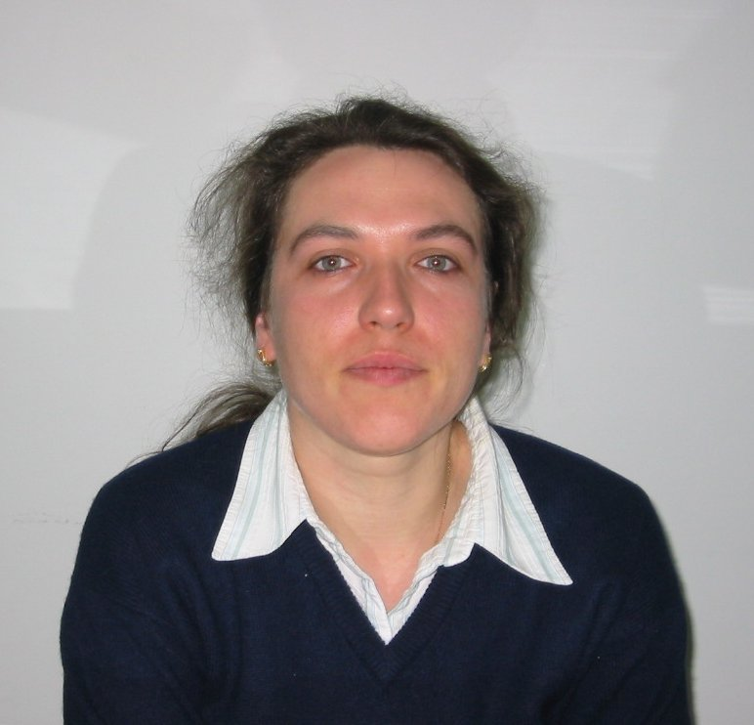
European
curriculum vitae
format

Personal information

Name |  | LUPU Nicoleta
Address |  | Soseaua Nationala 42 B, Bl. A1, Sc. D, Et. 4, Ap. 3, 700605 Iasi, ROMANIA
Telephone |  | +40-232-245014 / +40-744-902745
Fax |  | +40-232-231132
E-mail |  | nicole@phys-iasi.ro

Nationality |  | Romanian

Date of birth |  | 27, September, 1972

Work experience

• Dates (from – to) |  | September 2004 - present
• Name and address of employer |  | National Institute of Research and Development for Technical Physics, 47 Mangeron Boulevard, PO 3, PO Box 833, 700050 Iasi, Romania
• Type of business or sector |  | Research and Development
• Occupation or position held |  | Main Scientific Researcher, Head of the Laboratory of Magnetic Materials and Devices
• Main activities and responsibilities |  | Co-organized and coordinated research projects for the investigation of magnetization processes and coercive field mechanisms in amorphous and nanocomposite magnetic materials.  Organized and led research projects for the modeling of topological and magnetic structures in amorphous and nanocomposite alloys, as well as in nanomaterials (nanowires, nanopwders).  Theoretical and experimental studies on the mechanisms leading to the increase of the glass-forming ability in multicomponent magnetic systems and formation of bulk amorphous shaped alloys.  Theoretical studies on the interplay between microstructure and magnetic properties in bulk amorphous magnetic alloys.  Studies related to the application of bulk amorphous magnetic alloys in different conventional and novel applications.

• Dates (from – to) |  | September 2003 – September 2004
• Name and address of employer |  | National Institute of Research and Development for Technical Physics, 47 Mangeron Boulevard, PO 3, PO Box 833, 700050 Iasi, Romania
• Type of business or sector |  | Research and Development
• Occupation or position held |  | Main Scientific Researcher
• Main activities and responsibilities |  | Co-organized and coordinated research projects for the investigation of magnetization processes and coercive field mechanisms in easy glass-forming alloys with discontinuous magnetic structures.  Organized and led research projects for the modeling of topological and magnetic structures in amorphous alloys.  Theoretical studies on the interplay between microstructure and magnetic properties in bulk amorphous magnetic alloys.  Studies related to the application of bulk amorphous magnetic alloys in different conventional and novel applications.

• Dates (from – to) |  | September 1999 – September 2003
• Name and address of employer |  | National Institute of Research and Development for Technical Physics, 47 Mangeron Boulevard, PO 3, PO Box 833, 700050 Iasi, Romania
• Type of business or sector |  | Research and Development
• Occupation or position held |  | Scientific Researcher
• Main activities and responsibilities |  | Co-organized and coordinated research projects for the investigation of magnetization processes and coercive field mechanisms in easy glass-forming alloys with discontinuous magnetic structures.  Organized and led research projects for the modeling of topological and magnetic structures in amorphous alloys.  Theoretical and experimental studies on the mechanisms leading to the increase of the glass-forming ability in multicomponent magnetic systems and formation of the bulk amorphous shaped alloys.  Theoretical studies on the interplay between microstructure and magnetic properties in bulk amorphous magnetic alloys.  Studies related to the application of bulk amorphous magnetic alloys in different conventional and novel applications.

• Dates (from – to) |  | August 1997 – September 1999
• Name and address of employer |  | National Institute of Research and Development for Technical Physics, 47 Mangeron Boulevard, PO 3, PO Box 833, 700050 Iasi, Romania
• Type of business or sector |  | Research and Development
• Occupation or position held |  | Research Assistant
• Main activities and responsibilities |  | Conducted the process of research and development for the production of large glass-forming magnetic alloys as thick melt-spun ribbons, bars, cylinders, ring-shaped alloys.  Investigated magnetic and physical properties of bulk amorphous alloys as a function of their preparation conditions, thickness, cooling rate, microstructure, annealing procedure and thermal and magnetic history of the samples.

Education and training

• Dates (from – to) |  | October 1991 – July 1996
• Name and type of organization providing education and training |  | “Alexandru Ioan Cuza” University, Faculty of Physics, Iasi, Romania  University – High Education Institution
• Principal subjects/occupational  skills covered |  | Technological Physics
• Title of qualification awarded |  | Diploma of Physicist-Engineer
• Level in national classification  (if appropriate) |  | --

• Dates (from – to) |  | October 1996 – July 1997
• Name and type of organization providing education and training |  | “Alexandru Ioan Cuza” University, Faculty of Physics, Iasi, Romania  University – High Education Institution
• Principal subjects/occupational  skills covered |  | Physics of Thin Films
• Title of qualification awarded |  | M.Sc. Degree
• Level in national classification  (if appropriate) |  | --

• Dates (from – to) |  | September 1997 – July 2001
• Name and type of organization providing education and training |  | “Alexandru Ioan Cuza” University, Iasi, Romania  University – High Education Institution
• Principal subjects/occupational  skills covered |  | Preparation and Magnetic Properties of Bulk Amorphous Alloys
• Title of qualification awarded |  | Ph.D. in Physics
• Level in national classification  (if appropriate) |  | --

• Dates (from – to) |  | August 20, 2000 – September 23, 2000
• Name and type of organization providing education and training |  | Institute for Materials Research, Tohoku University, Sendai, Japan
• Principal subjects/occupational  skills covered |  | Nd-Fe-(Si,Al) Bulk Amorphous Alloys with Hard Magnetic Properties
• Title of qualification awarded |  | JSPS (Japan Society for the Promotion of Science) short-term fellowship
• Level in national classification  (if appropriate) |  | --

• Dates (from – to) |  | April 1, 2002 – August 31, 2002
• Name and type of organization providing education and training |  | LTPCM-ENSEEG, Institut National Polytechnique de Grenoble, France
• Principal subjects/occupational  skills covered |  | EU RTN-Network on Bulk Metallic Glasses (HPRN-CT-2000-0033) – “Preparation and Characterization of Fe-based Bulk Amorphous Alloys with Soft Magnetic Properties”
• Title of qualification awarded |  | EU RTN Post-doc Fellowship
• Level in national classification  (if appropriate) |  | --

• Dates (from – to) |  | June 1, 2003 – August 15, 2003
• Name and type of organization providing education and training |  | LTPCM-ENSEEG, Institut National Polytechnique de Grenoble, France
• Principal subjects/occupational  skills covered |  | EU RTN-Network on Nano-Al (HPRN-CT-2000-0038) – “Characterization of Amorphous and Nanocrystalline Materials by Means of Synchrotron Radiation”
• Title of qualification awarded |  | EU RTN Post-doc Fellowship
• Level in national classification  (if appropriate) |  | --

• Dates (from – to) |  | February 12, 2003 – February 10, 2003
• Name and type of organization providing education and training |  | Institute for Materials Research, Tohoku University, Sendai, Japan
• Principal subjects/occupational  skills covered |  | International Frontier Center for Advanced Materials (IFCAM) Project – “Development of Advanced Materials for Applications”
• Title of qualification awarded |  | IFCAM Post-doc Fellowship
• Level in national classification  (if appropriate) |  | --

• Dates (from – to) |  | October 27, 2004 – August 26, 2005
• Name and type of organization providing education and training |  | Institut Laue-Langevin (ILL) and European Synchrotron Radiation Facilities (ESRF), Grenoble, France
• Principal subjects/occupational  skills covered |  | EU Research Training Network “H-Sorption in MgH₂” (HPRN-CT-2002-00208) – “X-ray Powder Diffraction and SANS Investigations of the H-Sorption in MgH₂ Powders with Additives”
• Title of qualification awarded |  | EU RTN Post-doc Fellowship
• Level in national classification  (if appropriate) |  | --

Personal skills
and competences
Acquired in the course of life and career but not necessarily covered by formal certificates and diplomas.

Mother tongue |  | Romanian

Other languages

 |  | English
• Reading skills |  | Excellent
• Writing skills |  | Excellent
• Verbal skills |  | Excellent

 |  | French
• Reading skills |  | Excellent
• Writing skills |  | Good
• Verbal skills |  | Good

 |  | Japanese
• Reading skills |  | Basic
• Writing skills |  | Basic
• Verbal skills |  | Basic

Social skills  and competences  Living and working with other people, in multicultural environments, in positions where communication is important and situations where teamwork is essential (for example culture and sports), etc. |  | Ph.D. in Physics with extensive experience in the field of amorphous and nanocomposite metallic alloys, mainly magnetic materials with soft and hard magnetic properties, their magnetic properties, and applications. Excellent verbal, written, and interpersonal skills. Proficiency in reading/writing, speaking English, French and Romanian. Excellent social skills, including work with other people in multicultural environments.

Organisational skills  and competences  Coordination and administration of people, projects and budgets; at work, in voluntary work (for example culture and sports) and at home, etc. |  | Excellent skills in coordibation and administration of people, projects and budgets at work, considering the position as Head of the Laboratory and Director of different National and International Projects.

Technical skills  and competences  With computers, specific kinds of equipment, machinery, etc. |  | Excellent IT skills, including the use of new and innovative softwares. Excellent technical skills and competences in using specific equipments and devices for the preparation, characterization and applications od novel magnetic materials, and not only.

Artistic skills  and competences  Music, writing, design, etc. |  | No specific artistic skills.

Other skills  and competences  Competences not mentioned above. |  | Expert evaluator for national and European projects.

Driving licence(s) |  | --

Additional information |  | Publications (43, from which 34 in ISI journals) mostly concerning rapidly and slowly solidified alloy design, casting, and their magnetic properties  Over 50 papers, including invited ones, presented at national and international conferences, workshops, symposiums  32 citations in papers published in international journals, excluding self-citations  One book-chapter in collaboration: "Bulk amorphous magnetic materials" in "Properties and Applications of Advanced Magnetic Materials", Editors: Y. Liu, D.J. Sellmyer, D. Shindo, J.-G. Zhu, G.C. Hadjipanayis, Tsinghua University Press & Springer-Verlag, 2005.  Member in the Organizing Committee of ISMANAM’2005, Paris, France, July 2005 and ANMM’2005, Iasi, Romania, September 2005.  Editor of the ISMANAM’2005 Conference Proceedings – Special number of Journal of Alloys and Compounds, Elsevier Science.  PROFESSIONAL AFFILIATIONS: I.E.E.E. Magnetics Society, Materials Research Society, European Physical Society, Romanian Physical Society

Annexes |  | List of publications, Research Visits performed,. Invited Lectures.

